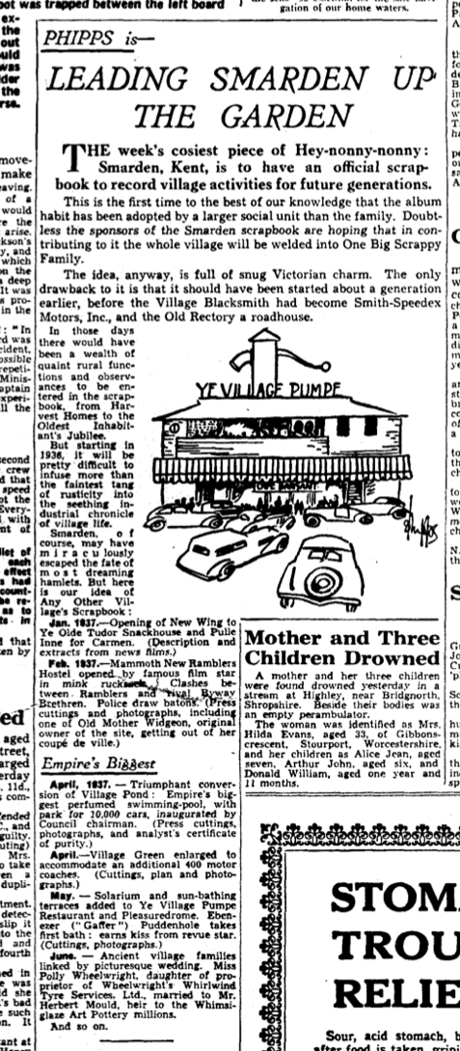
Figure 1 An article entitled 'Leading Smarden up the garden', published in The Daily Mirror on 15 October 1936.
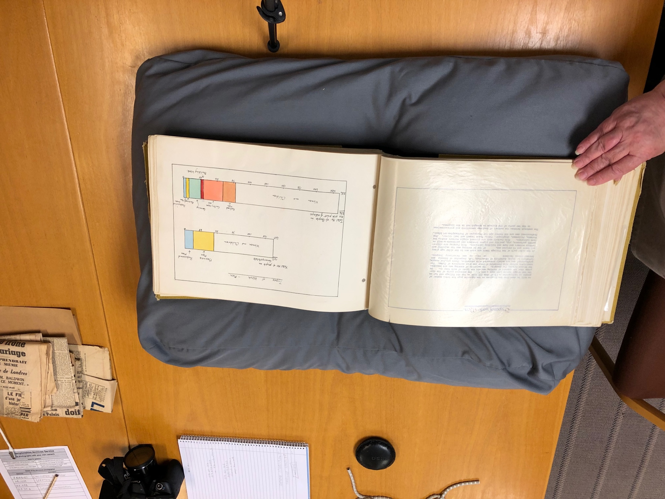

Figure 2 A page from Collingtree's entry to the NFWI's 1965 competition. Collingtree's submission was notable for its length and graphs inserted in its pages.
Source: Scrapbook 'Collingtree 1965' with monochrome and colour photographs, drawings and maps, ZB0445/2, Northamptonshire Record Office, Northampton.

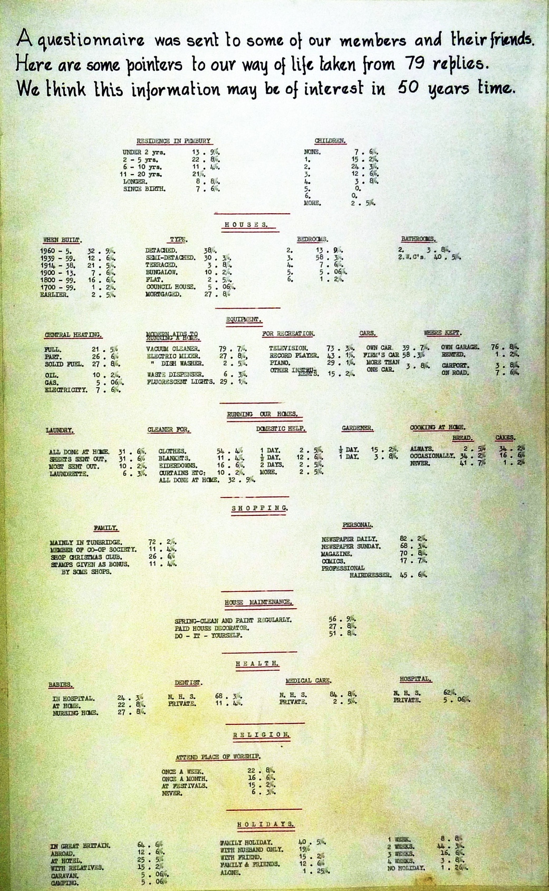
Figure 3 A page from Pembury's scrapbook showing some of the statistics on village life they collated as part for their village survey.

Source: "WI Scrapbook of 1965," Pembury Village, 1965, http://web.archive.org/web/20171212011407/https://pembury.org/history/archive/wi-scrapbook-of-1965/.
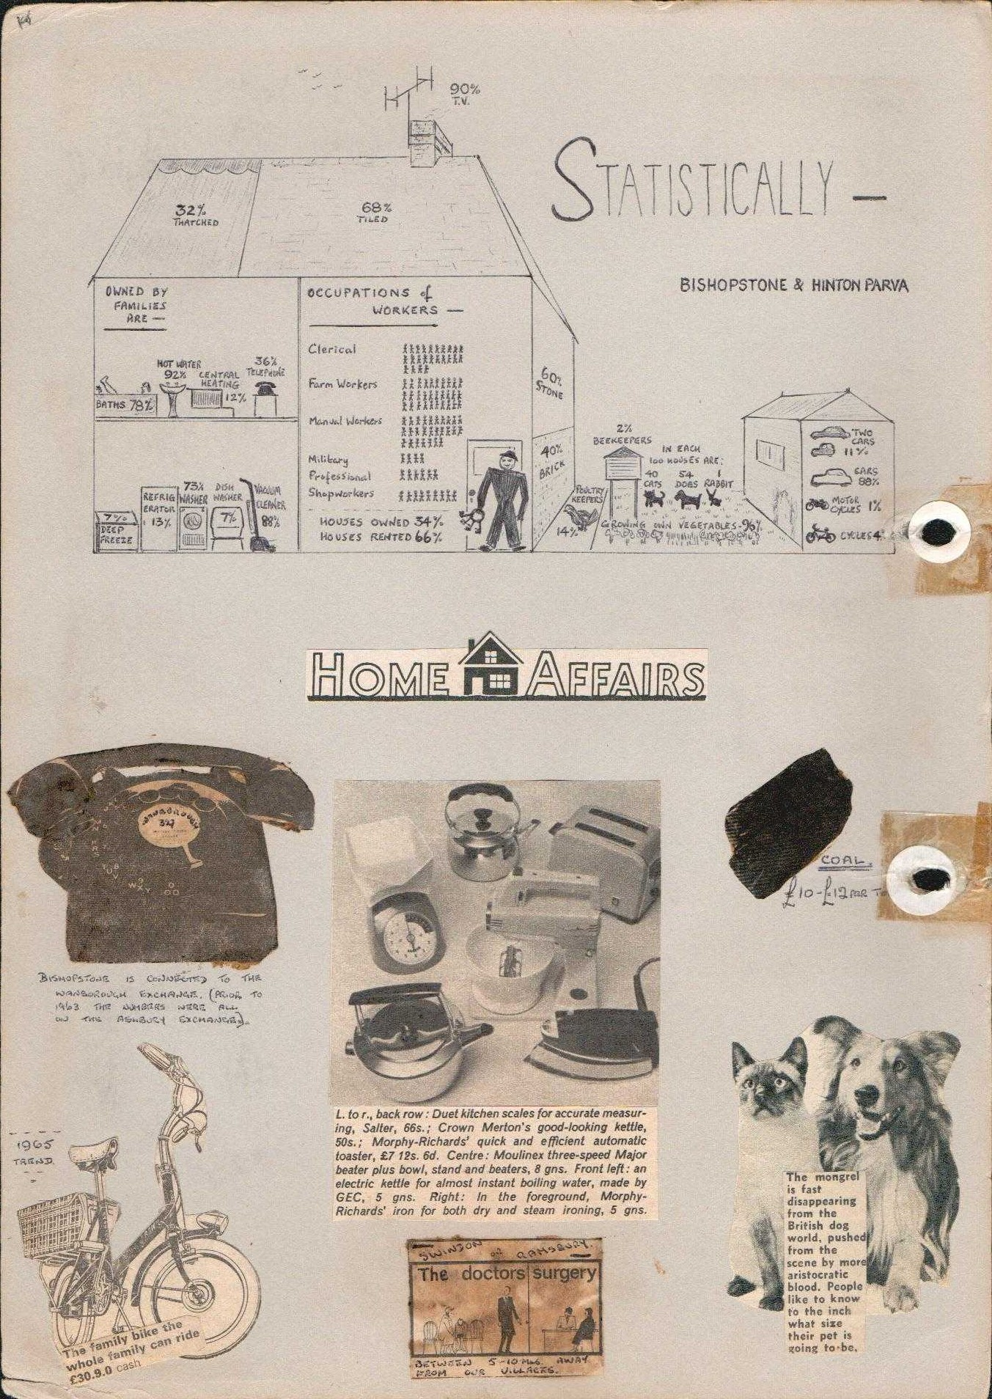

Figure 4 A visual representation of statistics compiled as part of Bishopstone and Hinton Parva’s 1965 scrapbook.
Source: "Womens [sic] Institute," https://bishopstoneandhintonparva.org/womens-institutue/.

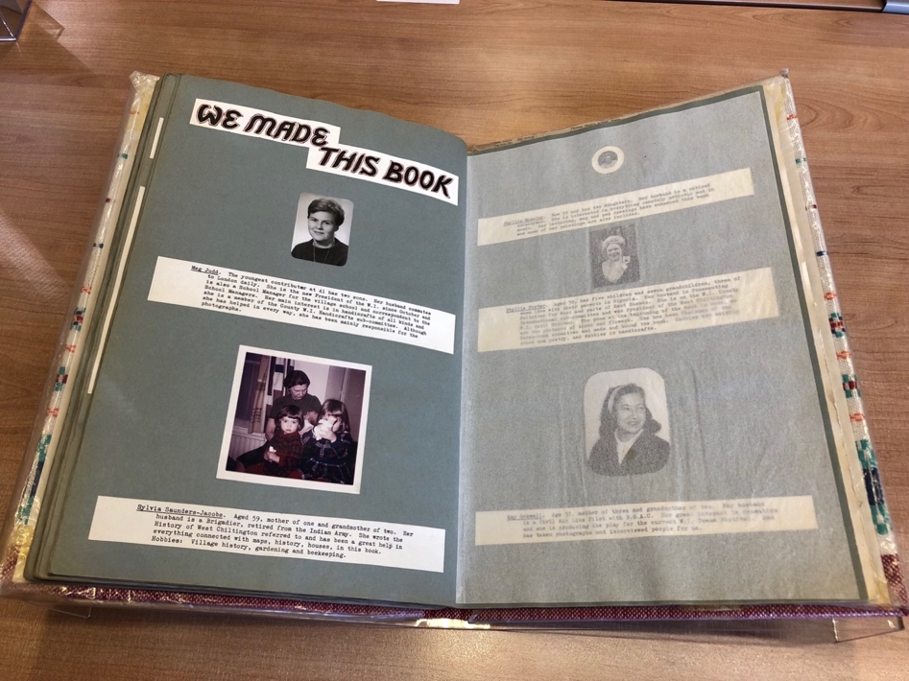

Figure 5 A double-page spread from West Chiltington's submission to the 1965 Jubilee Scrapbook competition, drawing attention to the compilers of the volume.
Source: West Chiltington WI, West Chiltington 1965, 1965, Miscellaneous Papers, MP/968, West Sussex Records Office, Chichester.
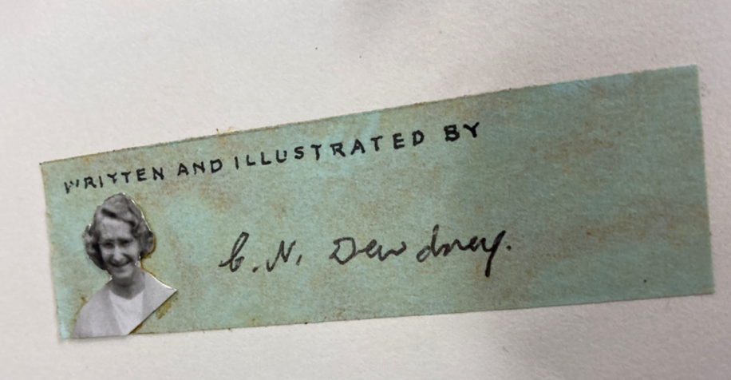

Figure 6 An example of a signed strip of paper inserted at the end of each section of Radwinter’s winning submission to the competition. Notice the care taken to create this one signature card: taking a photograph of the WI member, scaling it down to size, then cutting neatly around her profile. Each researcher had to sign her name before it was then pasted into the scrapbook itself.
Source: Radwinter WI, Radwinter Scrapbook 1965, 1965, Radwinter Women’s Institute Archive, Radwinter, Essex.
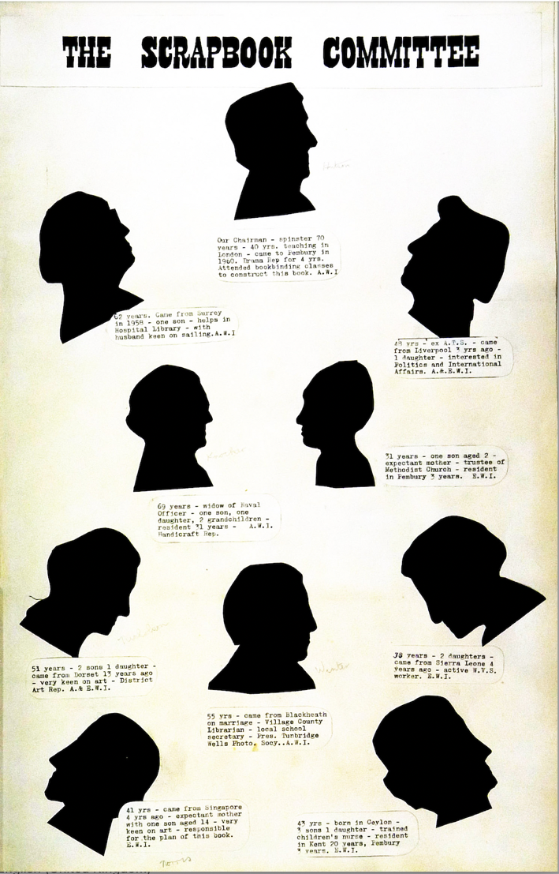

Figure 7 A page from Pembury's scrapbook containing short profiles of the compilers.
Source: "WI Scrapbook of 1965," Pembury Village, 1965, http://web.archive.org/web/20171212011407/https://pembury.org/history/archive/wi-scrapbook-of-1965/.
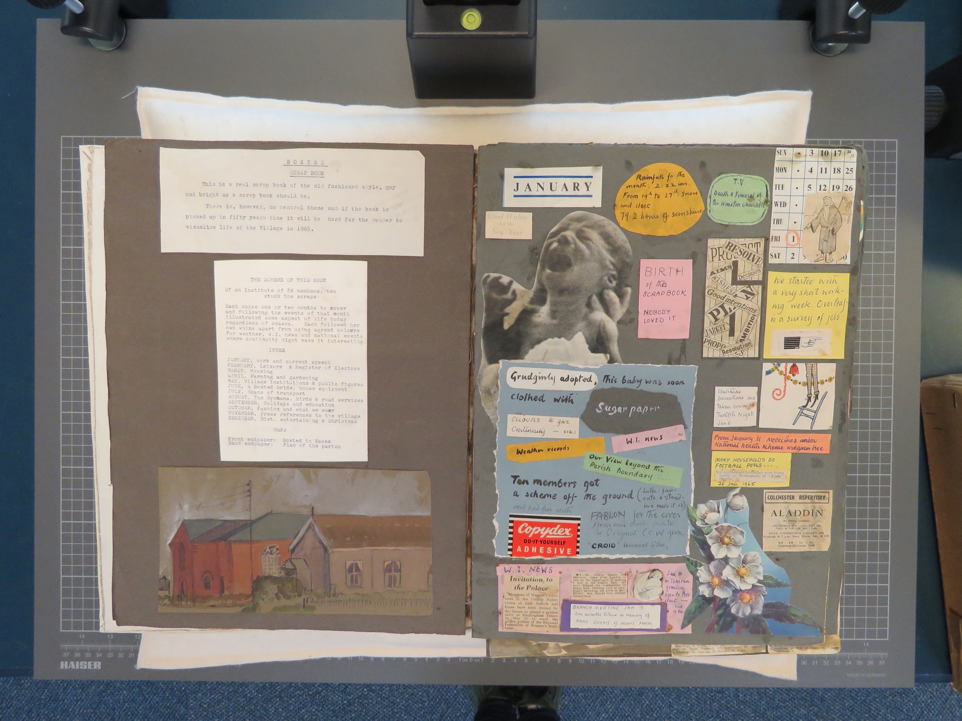

Figure 8 A page from Boxsted’s WI scrapbook, displaying their resentment at creating the volume, as they compare it to giving birth to a child.

Source: Boxsted WI, Boxted Today, 1965, D/Z 457, Essex Record Office, Chelmsford.

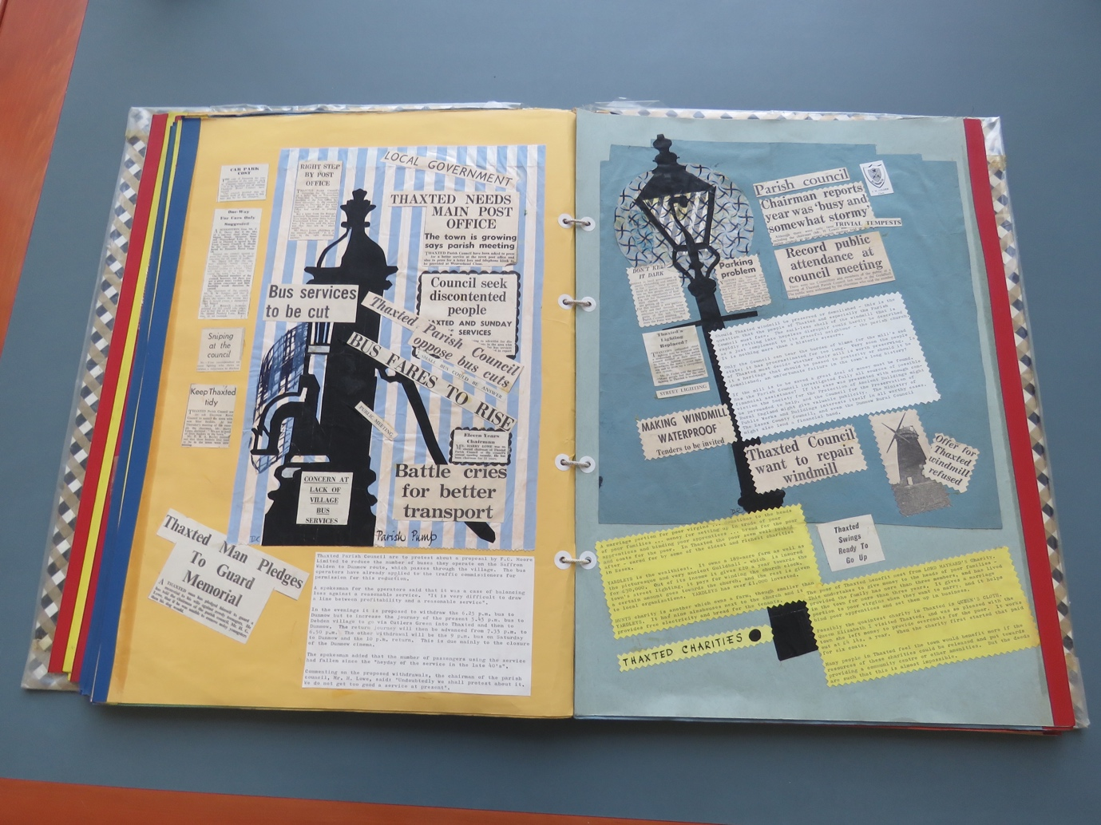

Figure 9 A page from Thaxted’s 1965 scrapbook using collage and montage techniques to register concern over changes to bus services.

Source: Thaxted WI, Thaxted Women's Institute scrapbook, 1965, T/Z 29/14: Essex Records Office, Chelmsford.

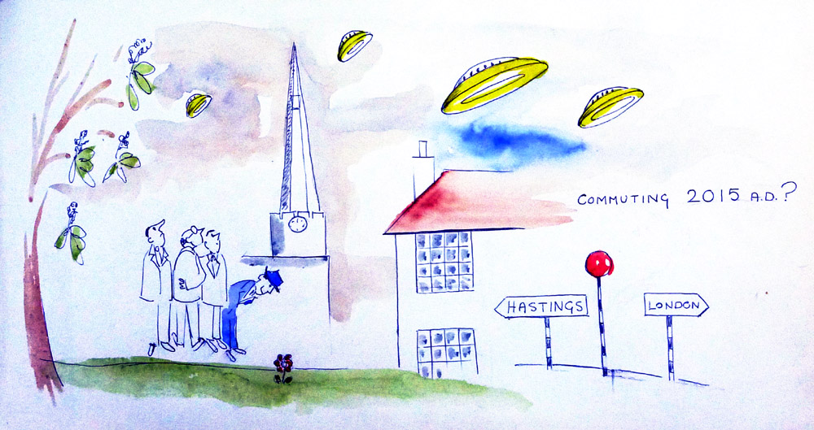

Figure 10 A watercolour drawing predicting the future of commuting in Pembury, Kent.

Source: Pembury Women’s Institute, “WI Scrapbook of 1965”, http://web.archive.org/web/20171212011407/https://pembury.org/history/archive/wi-scrapbook-of-1965/.

