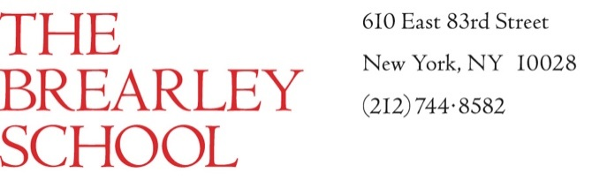

Middle and Upper School Teacher of History

The Brearley School, an independent girls’ school serving over 700 students K-XII, welcomes candidates for the position of Teacher of History in Classes VI-XII.

Founded in 1884, the school is a center of intellectual exuberance, attracting students from across and beyond New York City. Its mission has long combined outstanding academics with an insistence on larger purpose: we seek to prepare our students for principled engagement in the world.

A Brearley teacher loves to teach students who love to learn. She or he has the wisdom and skill to spark in them a pioneering spirit as well as the ability to think critically and creatively. We count on our faculty to create and maintain an atmosphere of honesty, generosity and genuine respect for the thoughts, efforts and feelings of others. Many are scholars, artists or athletes. We actively seek to build, nurture and sustain a diverse faculty and student body.

This position, like many at the school, entails cross-divisional teaching, which is an essential aspect of our program. We educate our students with a network of teachers who know them for years, who recognize that they flourish in their own time, and who know where the curriculum begins and how it will proceed. A Brearley education is rooted in ideas and practices that have been developed over time and through thoughtful, deliberate collaboration. We encourage new faculty to bring new ideas and fresh insights that might enhance a strong, beloved foundation.

The ideal candidate will have a genuine passion for and command of subject matter; a sincere interest in young people and an appreciation for the variety of ways in which they grow and learn; excellent communications skills; fairness, consistency and promptness in evaluating student work and in responding to students’ individual progress; the desire to collaborate; a collegial spirit and a sense of humor; and a commitment to helping students think independently and develop confidence in their own abilities.

Class size averages 13-16 students. A Brearley teacher also educates students through service in other areas, such as advising a small group of students, for example, guiding a club or chaperoning trips, and attending extracurricular events in which the students take part.

An advanced degree in History or a related field and 3-5 years of experience in teaching Middle or Upper School are preferred.

Interested candidates may apply for this position by completing an application and uploading a cover letter and resume at <https://www.brearley.org/page/about/employment-opportunities>.

The Brearley School is an equal employment opportunity employer committed to hiring exceptional, dedicated teachers of diverse backgrounds. We consider qualified individuals for employment with the School regardless of race, color, religion, national origin, sex, age, disability or any other state or federal protected classification.