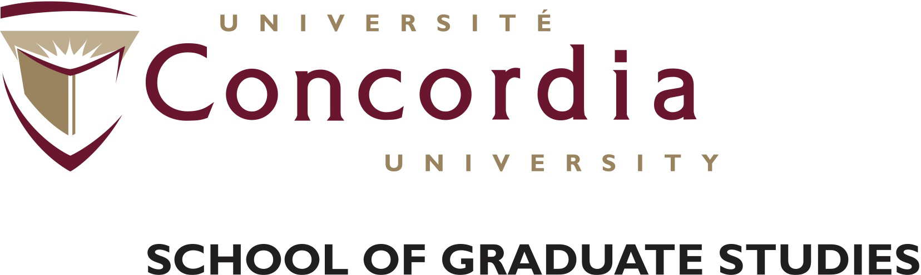

**Horizon Postdoctoral Fellowship   
at Concordia University**

Concordia University in Montreal, Canada is currently accepting applications for postdoctoral fellowships valued at $47,500 per year for 16 months, in the following discipline:

|  |  |
| --- | --- |
| Research program title: | Post-Doctoral Fellowship in Web Mapping/Online Education & Oral History |
| Supervisor(s): | Dr. Steven High, Department of History;  Dr. Sébastien Caquard, Department of Geography, Environment and Planning. |
| Program description (up to 200 words): | Based at the Centre for Oral History and Digital Storytelling and the Geomedia Lab, the Postdoctoral Fellow will contribute to the technological and/or the pedagogical development of the Living Archives Toolkit and Platform of the Rwandan Diaspora, a public online platform that will enable researchers, educators, students, and survivors themselves to access 34 recorded life story interviews. This program is supported by two interlocking SSHRC-funded projects and is developed in collaboration with Page-Rwanda, representing the friends and family of those lost in 1994.  The platform will be built on two existing open source applications: *Stories Matter* (<http://storytelling.concordia.ca/storiesmatter/>), developed by High and colleagues to enable the access to audiovisual life stories and *Atlascine*, designed by Caquard and colleagues to enable the mapping of stories in general <http://atlascine3.classone-tech.com/index.html>). Depending on her/his background and expertise, the postdoctoral Fellow will be in charge of either implementing methodological and technological solutions to enable the interfacing between *Atlascine* and *Stories Matter* or to develop the online living archive platform and associated pedagogical modules. This Fellowship is envisioned as a way to respond to the wider need to develop new ways to access, share, listen, visualize, map and analyse the recorded stories of survivors of mass violence. |
| Academic qualifications required: | The postdoctoral fellowship will bring to Concordia a university researcher (**open discipline**) interested in **online education** and/or in **digital tools development**. The candidate will need to demonstrate expertise in either digital pedagogical or computer programming. S/he will also need to demonstrate a capacity to work **collaboratively** with a range of partners, as well as a real interest in both **oral history** and **web cartography**. Speaking and understanding **French** will definitely be asset. Finally, the candidate will need to demonstrate an active publication profile since s/he will be involved in the academic dissemination of the results of this project through publications and oral presentations. |

Eligibility requirements:

* Applicants must not currently hold a postdoctoral appointment at Concordia
* Priority will be given to postdoctoral fellows who have obtained their PhD from another university although in exceptional cases Concordia graduates may be considered
* Applicants must adhere to the postdoctoral fellow eligibility criteria outlined in Concordia University’s Postdoctoral Policy

Timeline and Application Process:

Application deadline: December 8, 2017

Fellowship start date: January 8, 2018 (negotiable)

Submission process: all documents must be submitted to Steven High at [steven.high@concordia.ca](mailto:steven.high@concordia.ca) .

Application checklist:

* One to three (1-3) page research statement demonstrating fit with the program described above
* Current curriculum vitae demonstrating research excellence and a capacity for leadership in the domain (maximum 5 pages).
* Two letters of reference from academic supervisors or current employers to be sent via e-mail directly to: Steven High ([steven.high@concordia.ca](mailto:steven.high@concordia.ca) )

*Concordia University is a vibrant research and teaching environment, with state-of-the-art research facilities and many research centers. Concordia is located in Montreal, Canada, a diverse and creative city, often ranked as offering one of the best quality of living experiences in North America.*