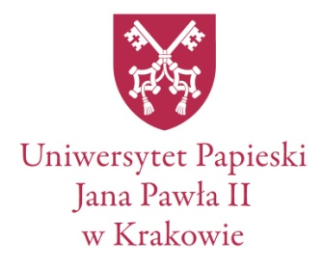

Ph. D. students’ conference

***Reforms, Institutions, Customs –***

***Conflicts over the Course of History***

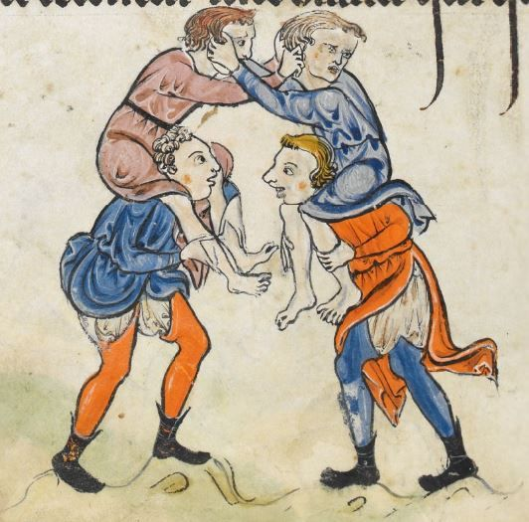

**Date:** 7–8 VI 2018 r.

**Place:** Krakow, Bernardyńska street 3

**Organised by:** Faculty of History and Cultural Heritage of Pontifical University of John Paul II in Krakow; Academic Association of Ph. D. Students of History

**Conference fee:** 80 zł (includes conference materials + catering)

**Abstract submission ultimate date:** 25 II 2017 r.

**Length of presentation:** 20 minutes

**Accommodation:** please contact us – we will help you find it.

**E-mail:** konferencja.upjp2@gmail.com

Academic Association of Ph. D. Students of History of Department of History and Cultural Heritage of the Pontifical University of John Paul II in Krakow invites you to participate in the conference, whose main subject are conflicts over the course of history. The title *Reforms, Institutions, Customs – Conflicts over the Course of History* is to be understood as an attempt to scrutinize the discords, disputes and conflicts over the course of centuries – all of them in the area of reforms, institutions and customs. Our invitation is addressed to Ph. D. students and researchers – in particular those, who are historians.

We encourage to deliver a presentation all the researches who, analyzing the processes that follow all reforms, found new reasons why no reforms can be carried out without causing conflicts and almost every change entails a disagreement.

We invite also those of you who explore the history of different institutions, especially those researches who worked on historical sources connected with conflicts between institutions. There are many sources where we can find information about historic conflicts in the context of some institutions that struggle against one another, for example in the area of prerogatives, especially when they overlapped.

Finally, we invite those who, researching traditions, customs and rites came across a documented resistance against them. We are interested in all types of negating the status quo, established order, fixed social and economic rules.

Furthermore, we invite the scientists, whose research includes human conflicts, disagreements, antipathy, tenacity, disputes and personal confrontations both between prominent figures and between ordinary people. In the course of these two days we would like to discuss the reasons for conflicts, their course and results. We also pay attention to the positive aspect of conflicts: is consensus and reconciliation possible in the context of reforms, institutions and customs or does the unleashed conflict last until whichever side of it still exists?

The conference formular can be found on

<https://docs.google.com/document/d/1SW2Bqv4ke8GPFFH9uCik9g2qzrKGEUqVDRCYHGlMpQc/edit>

The abstract, which is to be included in it, should have about 250 words. Please, include also a bibliography, paying special attention to historical sources. We plan to publish the best papers in a reviewed, highly scored journal “Folia Historica Cracoviensia” (more information: after announcing the list of speakers).

We are looking forward to see you in June!

Organising committee:

dr hab. Józef Cezary Kałużny

mgr Dorota Żywczak

mgr Anna Makarczyk

mgr Jan Bulak

mgr Daniel Marek