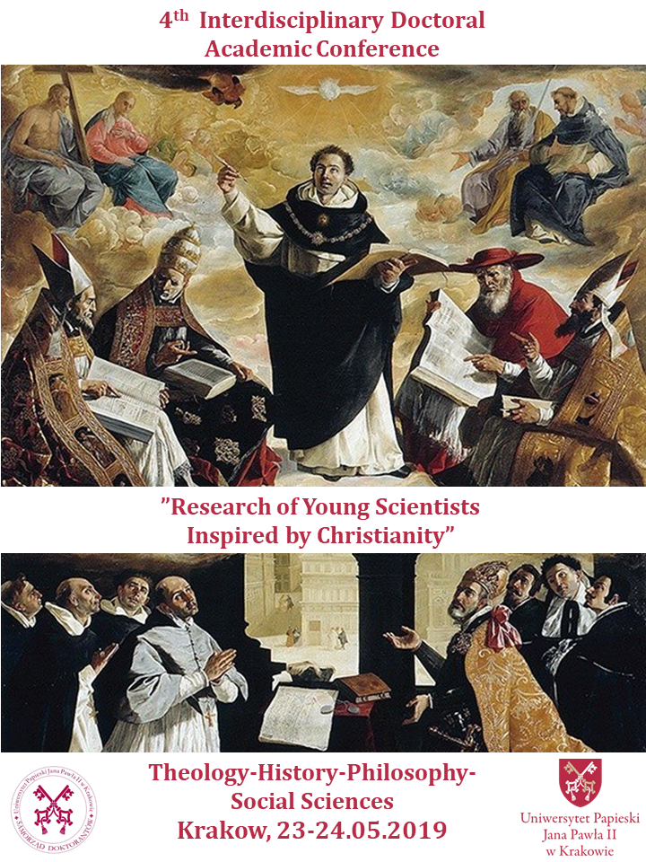

**Doctoral Government of the Pontifical University of John Paul II in Krakow**

**is pleased to announce a call for papers for the** **4th interdisciplinary doctoral academic conference**

**”Research of Young Scientists Inspired by Christianity”**

The conference will take place on **23rd–24th May 2019** in Aula of the building of Pontifical University of John Paul II in Krakow at Bernardyńska Street 3.

We invite all PhD students and young scientists specialising in widely understood humanities, in particular:

* **theology** (including as well: biblical/historical/semantic theology)
* **history** (including as well: archeology, historiography, archival science)
* **arts** (including as well: art. history)
* **philosophy** (including as well: social/political philosophy, ethics, bioethics, aesthetics, anthropology, ecophilosophy)
* **social sciences** (including as well: family science, sociology, social politics)
* **canon law** (including as well: ecclesiastical/concordate law)

The organizers of the conference want to create an interdisciplinary space for exchange of research thoughts and experiences between the representatives of various branches of humanities. The key word for all these scientific reflections is supposed to be **CHRISTIANITY**, which since the first centuries of its existence constituted an inexhaustible source of inspiration for theological intellectualisation, historical research, works of art, philosophical delving, social thought or legal solutions. During the conference young academics will have an opportunity to present their research outcomes connected at least to some extent with the phenomenon of Christianity –from its beginnings until nowadays.

**Conference languages:** Polish, English

**Length of contribution:** 20 minutes

**Registration:** All those interested in the active participation in the conference are kindly asked to download the application form from: <https://docs.google.com/document/d/1TP8xFezKXQ0fIGS7FyObdyJ9Qdy5zCDMDzkKCYM3SeQ/edit>

Please, send a filled-in formular to our e-mail: [**mlodzinaukowcyupjp2@gmail.com**](mailto:mlodzinaukowcyupjp2@gmail.com)by **10th March 2019** at the latest. You will get a feedback concerning your application by **24th March 2019**. Conference fee amounts to **50 PLN/12 €** and includes coffee breaks, lunch and conference materials.

**We are looking forward to see you in Krakow in May!**