Job Market Page:

The Departmental [job market page](https://econ.columbia.edu/phd/job-market-candidates/) which is set to go live September 30th.

PhD job market candidates must use the student profile page template for their job market page. The template autofills specific information to the job market page:

1. Name (with link to webpage)
2. Fields
3. Job market paper title (with link to abstract or full paper---if you have an abstract only once the site goes live, it must be added as a PDF). As a general rule, students add a version of the job market paper by the end of October.
4. Sponsor info. (link to email)

See last year’s candidate page for reference. Even if you have your own website, you must input basic information listed above for your name to appear on the Dept. job market page. Here are the [Directions](https://econ.columbia.edu/wp-content/uploads/sites/41/2017/10/creating-your-student-webpage-on-the-Econ-website.pdf) to create the webpage using department template.

If you have already created a personal webpage that is different from the department template, you can use the "page forwards to - a custom URL" box at the bottom to put in your own site. That way, when someone clicks on your name from the page it will forward to either the Columbia template or your personal site. Note: The Econ community will not be able to see a Google site while logged in to Lionmail and must sign in with a different account.

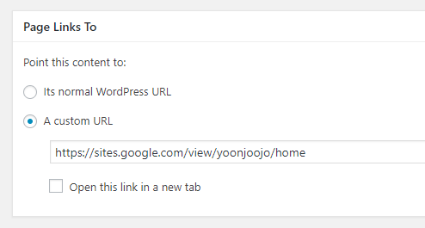

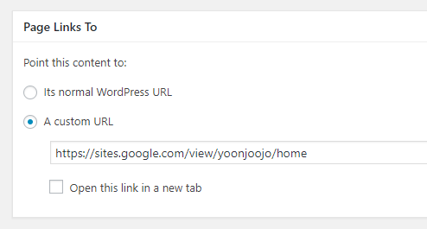

Your information will not be published on the Department job market page until your status is changed from PhD candidate to job market candidate on the [Student Profile](https://asit-prod-web1.cc.columbia.edu/econdept/wp-admin/edit.php?post_type=e) Page. I will remove all of the currently-posted job market candidates pages at 9am on 9/30 and update your status to job market candidate at that point.

**Title\***

Until you are on the job market, please select "PhD Candidate"

 Job Market Candidate

 PhD Candidate

The Department job market page also includes a CV packet. You will have the opportunity to send me an updated CV every Friday once the page goes live. There is a CV [template](https://docs.google.com/document/d/1dzE2N2oTWY5kKtY8F0ZzhS1op0-mxrwm/edit) in the Job Market Resource section—see Econ Dept Forms and Templates. If you update an item such as your job market paper title or abstract please be sure to update it everywhere:

-your CV

-your personal page

-department job market page

Once they posted the complete JMP, previous job market candidates have added a “click here” link to the most recent version—see Miguel Acosta’s paper [link](https://econ.columbia.edu/wp-content/uploads/sites/41/2021/09/acosta_jmp.pdf) on the Dept. job market candidate page.